February 3, 2015
ACORN Clinic is able to provide high quality health and dental care at low costs due in large part to the exceptional medical and dental community of Gainesville and outlying areas. Members of this extraordinary community regularly volunteer their time to help the disadvantaged rural residents of North Central Florida.
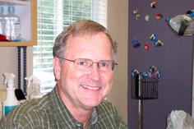
"All I have is heaps of praise for ACORN Clinic. It's all about patient care and helping people in need"
- Dr. Edward Herod, DDS -
Dr. Herod volunteers in the dental clinic two days a week. When not volunteering at ACORN Clinic he travels all over the world taking his talent for teeth to countries such as Zambia, Guatemala, Mexico, Peru and Cambodia to provide volunteer dental care. Most recently he traveled to Alaska to volunteer for the Indian Health Service to provide dental care to the Inuits.
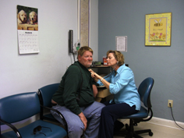
"We believe health care is best accomplished through an unbroken chain of small, personal actions and interactions, among the members of our staff, our patients and the larger community. The story of how we have arrived at that belief and how it sustains us is the story of a committed group of volunteer professionals and the work they do simply because it is the right thing to do."
- Lisa Molitor Gearen, ARNP -
Peter and Lisa Moliter Gearen volunteered for 30 years before Lisa joined the staff as ARNP in 2010.
If you are a healthcare or dental professional and are interested in volunteering some of your time to a worthwhile and rewarding cause, please visit the ACORN Clinic website at www.ACORNClinic.org. Look for the Volunteers tab in the navigation bar.

