July 8, 2016
Dr. Robert Thoburn wrote this testimonial about his long-time volunteer service at ACORN Clinic. Dr. Thoburn is also ACORN Clinic’s June Volunteer of the Month.
Healthcare in the United States costs twice as much as it does in other developed countries such as Canada, New Zealand and the United Kingdom. Additionally, half of all healthcare spending goes towards only five percent of the American population. Statistics such as these, are some of the many reasons why a place like ACORN Clinic, in Alachua County northeast of Gainesville, exists to help low-income families who need healthcare but are unable to afford it. When you hear a patient say, “ACORN Clinic saved my life” you can imagine the Clinic’s lasting impact for them and their families. This means that grandparents can have more time with their grandchildren, parents can have better quality time with their children, and kids can just be kids.

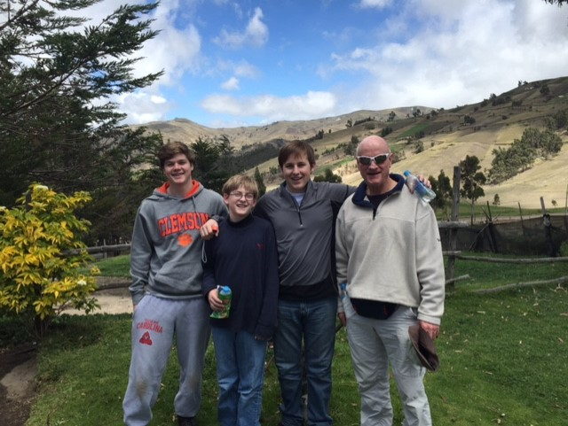Dr. Thoburn (far right), a long-time volunteer for ACORN Clinic, with his grandsons (from left) Adam, Koen, and Connor while trekking the Andes.

I have volunteered for over 15 years providing care as a rheumatologist treating arthritis and autoimmune diseases at ACORN Medical Clinic. ACORN Clinic is an oasis, a place where people in need can come for healthcare, with some, but not all the solutions to their health problems. The clinic is continually seeking new ways of providing the care that our patients need and deserve. In addition to treatment, clinic staff and volunteers support patients in making healthy choices in their lifestyle, which can make an enormous difference in their quality of life. As a specialist in a field benefiting from new understanding of genetic and molecular components of disease, I believe that patient education in the disease process and action of their medications has never been more important.
The delightful patients attending the ACORN Clinic come from all over the region. They are primarily those that, for various reasons, lack an ability to pay or have no health insurance. Many have not had good educational opportunities or other hindrances placing them at a higher risk for disease. Some have physical or mental disabilities that prevent them from having gainful employment.
Combined with insurance and financial problems, it can be quite challenging to find ways of diagnosing and treating these patients. Lab tests, X-rays, imaging studies, consultations and hospitalization can be expensive. Similarly getting physical and occupational therapy, dietary advice, psychological counseling and other healthcare can be challenging. Developing creative alternatives is part of the challenge and stimulation of volunteering as a physician at ACORN Clinic. Unfortunately, some healthcare advances are still out of reach for many of the Clinic’s patients.
Despite these challenges, it is gratifying to volunteer at ACORN for many reasons. For example, there is ample time to see each patient, allow them to tell you what is wrong with them, and do deep dives into their medical, social, genetic, and psychological environment. The family situation, living conditions, children’s problems, single parenting, mental illness, education, and disability can relate to their medical condition and its outcome.
ACORN has also given me the opportunity to delve more deeply into many of my patient’s circumstances. A moment that sticks out to me involves an elderly Russian woman visiting her daughter (who served as her interpreter) and who was also considering moving to Gainesville. She lived in a small town four hours west of Moscow, in a first floor apartment, surrounded by friends and long-time neighbors who grocery shopped for her and assisted with transportation. She struggled with the dilemma of transitioning from the known to the unknown with a language barrier, and she had disabling osteoarthritis of her knee without the financial resources for a needed knee replacement. Had her medical visit been limited to her arthritis, the image of this woman regarding her clinical care would have been woefully incomplete.
Moments such as these shows how being completely invested in your patients can really make a difference. In essence, the beauty of ACORN relies on the fact that we try to be as personable with our patients as possible. I can recall meeting an elderly African American woman with recent onset of shoulder pain, which had limited her daily activities and her sleep. My treatment and a simple phone call to her two weeks later found her highly appreciative of the call and a near resolution of her pain. This showed me that by simply following up with your patients to see how they are doing can really make an impact in their lives because it lets them know you truly care even beyond treating their illnesses. I have found that there is no better feeling than putting a smile on patient’s face by an unassuming gesture of kindness and regard for them as a fellow human being first and patient a second.
For these reasons, I believe ACORN Clinic is a safe haven, where people in need can come for desperately needed healthcare, with some, but not all the solutions to their health challenges. I continue to support ACORN Clinic and its mission through the gift of my time and expertise. I challenge the community to support ACORN through donations to its Capital Campaign to repair and update its buildings and equipment thereby allowing the Clinic to expand the number of patients it serves. Visit ACORN Clinic’s Website to learn more about how you can help: acornclinic.com/contribute
ACORN Clinic is a 501 (c)(3) non-profit serving 20 North Central Florida counties with full-service medical and dental clinics. ACORN Clinic provides high quality, affordable medical care, dental care, and social services by staff and volunteers. In partnership with educational institutions, ACORN Clinic also functions as an exemplary service learning site for health professionals.

