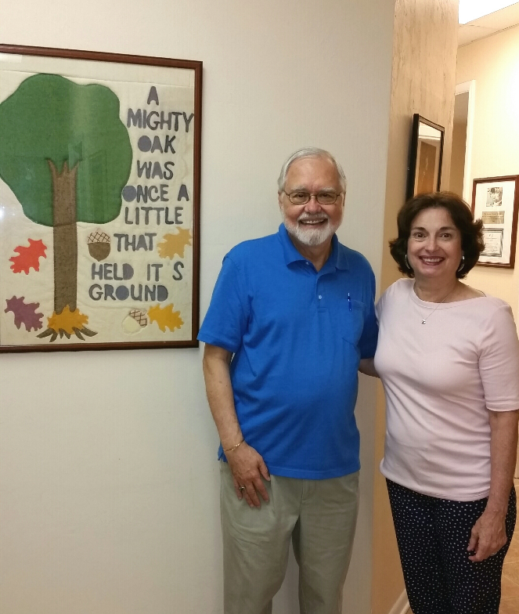

For several years I represented Union and then Alachua counties on the (now defunct) Regional Health Planning Council. The Council’s deliberations helped me to understand the plight of low income rural residents in medically underserved areas. I discovered a bright spot in an otherwise bleak picture: the ACORN Clinic. This non-profit facility, staffed mainly by volunteers, provides medical and dental services to residents of primarily Alachua, Bradford and Union counties.
Today more than ever, health care costs and access are concerns of the majority of our citizens. I have spoken with many who have benefitted from low-cost or no-cost medical care at ACORN, and they know their lives are better as a result of the Clinic’s efforts. I am always happy to support the work of the ACORN clinic and its staff as they meet a critical need.

Jim Galloway – Friend of ACORN

