July 19, 2016
Karen Autrey is also celebrated as ACORN Clinic’s May Volunteer of the Month.
Some might find it nearly impossible to have a successful career that spans over three decades while volunteering in the community and raising four children including twin boys. However, with a great amount of determination, tenacity, and A LOT of spunk, Karen Autrey has made the impossible a reality.
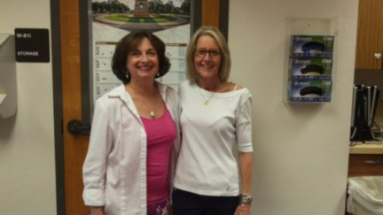
Candice King and Karen Autrey pose for a photo during Autrey’s retirement party.

Autrey began her career after receiving her degree in dental hygiene. In 1978, she started working in the dental school at Santa Fe College in Gainesville, Florida, becoming the director of the dental program in 2001.
During her time at Santa Fe College, Autrey started volunteering with ACORN Clinic. Autrey remembers being at ACORN when the facility was just a small, isolated trailer in an empty lot.
“It’s been remarkable seeing what ACORN has been able to do from starting small to now being able to offer a full range of dental and medical services,” she said.
During her many years at ACORN Clinic on the Board of Directors, Autrey was the supervisor of the dental hygiene volunteers and students. She explained the importance of having students volunteer at a facility like ACORN Clinic.
“Working at ACORN teaches these students that they can give back to their community,” she said. “It’s the most valuable clinical experience they will ever receive.”
Outside of volunteering, Autrey is embarking on a new chapter in her life. We would like to congratulate Autrey on her recent retirement after a very long and successful career.
“I have no other plans besides relaxing for a while,” she said. “My goal right now is to be able to sleep in more often and work on my jewelry making.”
We’re so thankful to have someone like Karen as a Friend of ACORN clinic. Thank you for everything!
Written by Mahogany Brown

